**CRIM 0562 - IFS Configuration Specification - Company and Customer Default Bank Account Fields**

|  |  |  |  |  |
| --- | --- | --- | --- | --- |
| **Ver** | **Date** | **Author** | **Comments** | **Reviewed by** |
| 1 | 25/02/2021 | Tom Bell | CRIM 0562 | TBC |
|  |  |  |  |  |

Requirements 2

Prerequisites 2

Solution Overview 2

Solution Details 2

Security 3

Companies 3

Data Migration 3

Test Steps 3

Technical Implementation 3

Requirements

A custom field is required on the Application Base Set Up > Enterprise > Company > Company screen, Invoice Tab, Default Invoice Type tab called “Default Invoice/Statement Bank Account”.

A custom field is required on the Application Base Setup > Enterprise > Customer > Customer screen, Payment tab called “Override Default Invoice/Statement Bank Account”.

Prerequisites

<Describe any pre-requisites that this development may rely upon, data configuration or other developments>

Solution Overview

Company Screen – “Default Invoice/Statement Bank Account” field

A custom field is required on the Application Base Set Up > Enterprise > Company > Company screen, Invoice Tab, Default Invoice Type tab called Default Invoice/Statement Bank Account.

When selected the field will show a list of values from the Financials > Payment Basic Data > Cash Book > Cash Accounts screen. One Cash Account is selectable in this field.

Customer Screen – “Override Default Invoice/Statement Bank Account” field

A custom field is required on the Application Base Setup > Enterprise > Customer > Customer screen, Payment tab called “Override Default Invoice/Statement Bank Account”.

When selected the field will show a list of values from the Financials > Payment Basic Data > Cash Book > Cash Accounts screen. One Cash Account is selectable in this field.

When creating a new customer this field is auto-populated with the data from the– “Default Invoice/Statement Bank Account” field on the Company Screen.

Solution Details

Default Invoice/Statement Bank Account field - Company Screen

The below screenshot shows where the custom field “Default Invoice/Statement Bank Account” field should be located.

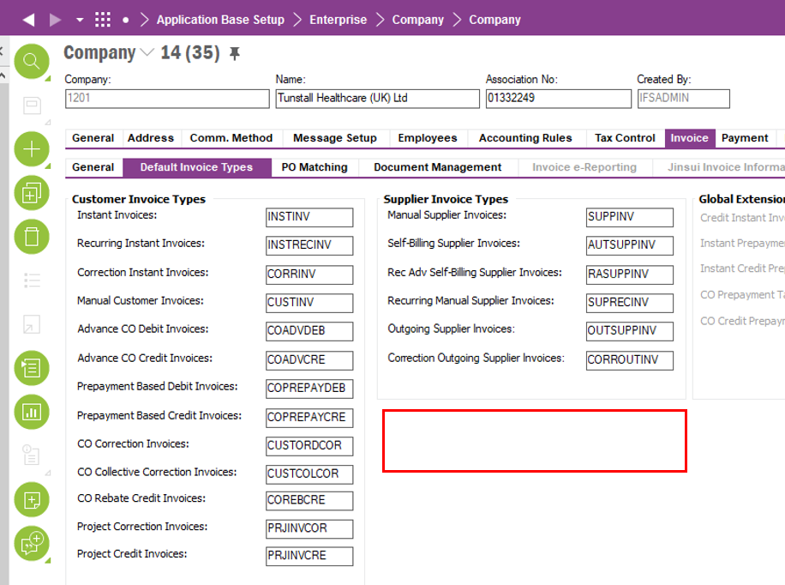

The below screenshot shows the data source that the list of values that this custom field should show. A single Cash Account should be selectable and populate the field.

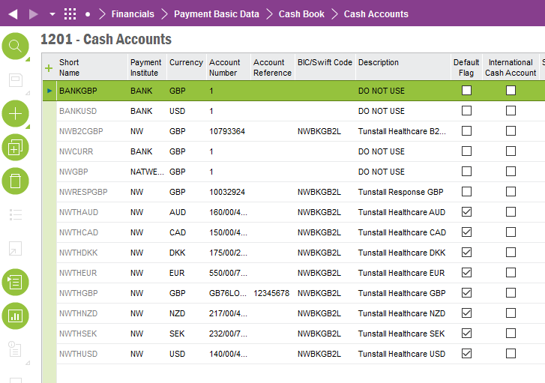

Override Default Invoice/Statement Bank Account field - Customer Screen

The below screenshot shows where the custom field “Override Default Invoice Statement Bank Account” field should be located. This field should auto-populate with the data from the “Default invoice Statement Bank Account” field (Company screen) from the company screen when creating a new customer.

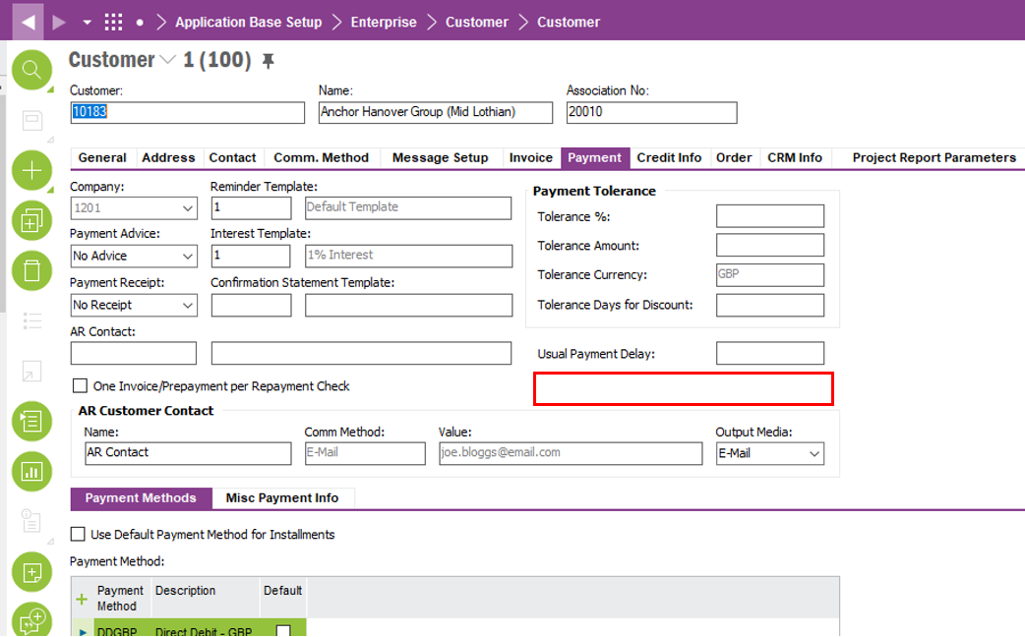

The below screenshot shows the data source that the list of values that this custom field should show. A single Cash Account should be selectable and populate the field.



**Technical.**

Field Definitions.

<New Field/CLU Definition>

|  |  |  |  |  |  |  |
| --- | --- | --- | --- | --- | --- | --- |
| New DB Object Name | DB Object Item/Field Names | Item Description | Item Data Type | Item Syntax | Calculation Spec, if Derived | LOVs/Enums/Is Mandatory? |
|  |  |  |  |  |  |  |
|  |  |  |  |  |  |  |
|  |  |  |  |  |  |  |
|  |  |  |  |  |  |  |
|  |  |  |  |  |  |  |
|  |  |  |  |  |  |  |
|  |  |  |  |  |  |  |
|  |  |  |  |  |  |  |
|  |  |  |  |  |  |  |
|  |  |  |  |  |  |  |
|  |  |  |  |  |  |  |
|  |  |  |  |  |  |  |

Security

<Define security controls> (Who needs access to this and will it be restricted from any other users etc)

**Financial Accounts**

Companies

Applies to the following companies. All.

|  |  |
| --- | --- |
| **Company** | **Required (Y/N)** |
| 1201 | Y |
| TBC |  |
|  |  |

Data Migration

<Describe any data migration impacts this development may have – i.e additional data to be migrated>

Test Steps

<Steps that needs to be taken to test this change. Please provide expected results> Updated post solution.

|  |  |  |
| --- | --- | --- |
| **No** | **Script\Test Steps** | **Expected Result** |
| 1 | Navigate to Application Base Set Up > Enterprise > Company > Company screen, Invoice Tab, Default Invoice Type tab and “Default Invoice/Statement Bank Account” field. | When selected the field will show a list of values from the Financials > Payment Basic Data > Cash Book > Cash Accounts screen. One Cash Account is selectable in this field. |
| 2 | Navigate to the Application Base Setup > Enterprise > Customer > Customer screen, Payment tab called “Override Default Invoice/Statement Bank Account”. | When selected the field will show a list of values from the Financials > Payment Basic Data > Cash Book > Cash Accounts screen. One Cash Account is selectable in this field. |
| 3 |  |  |
| 4 |  |  |
|  |  |  |
|  |  |  |

Technical Implementation

<Completed by the technical developer - Technical solution, list packages, functions, Custom menus created etc >

**Package**

EA_FINANCE

**Permissions granted**

IFS_ALL

**Custom Fields**

Company Window

Note: If the custom filed is not available in the layout, RMB on the Default Invoice Types Tab, Object Properties, and make sure to tick the highlighted tick boxes below and add the filed to the layout.

Customer Window

Note: If the custom filed is not available in the layout, RMB on the Payment Tab of the Customer Window, Object Properties, and make sure to tick the highlighted tick boxes below and add the filed to the layout.

